My findings and FREPA
Three steps:

- Step 1:
Write down (some of) your findings concerning the question “Which elements of knowledge can be developed by students while working with the material Some languages of Europe … and elsewhere?
Knowledge
My findings | FREPA items

(Just indicate
the number)
- Step 2:
Look at the knowledge items proposed by FREPA (http://carap.ecml.at/Descriptorsofresources/Knowledge/tabid/2407/language/en-GB/Default.aspx)
Don’t hesitate to “open” or “close” the main categories with “view descriptors” and “close”. A first overview of the main descriptors will offer you a first orientation through the whole variety of items.
- Step 3:
. Write down the FREPA item(s) which seem(s) to correspond with your findings.
. If you don’t find any corresponding element, discuss it with other participants (if any) and/or have a look at the Annex about the possible reasons for the lack of corresponding items.

Please, do the same (the three steps) with the Attitudes and Skills!
You will find below the tables and the links you need:

Attitudes
My findings | FREPA items

For Step 2: Look at the Attitudes items proposed by FREPA

Skills
My findings | FREPA items

For Step 2: Look at the Skills items proposed by FREPA

Possible reasons for the lack of corresponding items

- The knowledge (attitude, skill) you have opted for is not specific enough to pluralistic approaches.
You will for sure have noticed that the authors have distinguished between three levels of usefulness for the FREPA items:
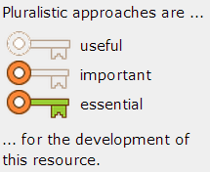

This decision is justified as follows in FREPA – Competences and resources (p. 17):

“The question we raise here for each resource we have included in the lists is to know how far its inclusion is justified in the context of our stated aim of creating a framework of reference for pluralistic approaches.
While certain resources which bring several languages into play (Can compare languages, Can carry out transfers between languages…) or which are related to diversity as such (Knowing that there are similarities and differences between languages, Receptiveness to the plurilingualism and pluriculturality of near and distant environments…) seem impossible to develop outside approaches which include activities related to several linguistic and cultural varieties at the same time (cf. the very definition of pluralistic approaches, in 1.2 above), numerous other resources can be developed by both pluralistic and non-pluralistic approaches.
Rather than attempt to create a dichotomy which would be impossible to apply and which would have excluded resources from our lists which, while not exclusive to pluralistic approaches, are developed to a considerable degree by them, we have established a three-point scale, the rating of which is included in the lists for each of the descriptors:”
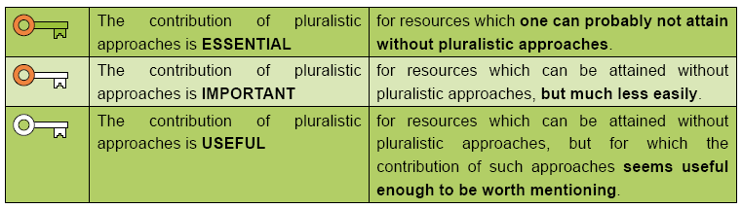

Maybe it is the case that the contribution of pluralistic approaches to the knowledge (attitude, skill) you have opted for has been considered as not useful enough to be worth mentioning.

- What you have opted for is not a (possible) result of working with pluralistic approaches….
This occurs very often when speaking about “objectives” of teaching. There is a possible confusion between
  - what the teacher intends to do in class (during the teaching event) (example: “to stimulate curiosity”)
  - what she/he is expecting from it in terms of capacities acquired by pupils (example: “is curious”).
The items presented in the FREPA lists belong to the second category.

- Your proposal is too “global”

As you will also see later on in our Discovery module, the FREPA distinguishes between Competences and Resources (= Knowledge, Attitudes, Skills). Competences mobilise several Resources in a given situation. For instance (cf. FREPA – Competences and resources, p. 83-89):

The competence of Adaptability in approaching what is other, different requires the activation of resources like:

Knowledge
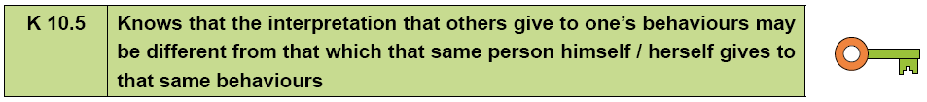

Attitude
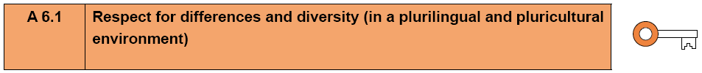
Skill:

Maybe your proposal belongs to the level of Competences, and you should try to find out some “components” contributing to it, which could in fact correspond to the FREPA Resources.

If none of these reasons applies, you may have found an item forgotten by the FREPA Authors!

The term Resource is used for Knowledge, Attitude or Skill. This will be dealt with later on in our Discovery module.

