James Hansen, City of Oulu
(some clarifying additions by Eija Ruohomäki)
the process of creation of the Oulu adaptation, Language and Culture Grids

Within the framework of the grid, we have intended to show the growth that students will be aiming to achieve within their understanding of the various cultural aspects, which they will face, both at school and in their general lives. We wanted to build something akin to Blooms Taxonomy (Division into ordered groups or categories) of Cognitive Levels those being:-

Knowledge

Comprehension

Application

Analysis

Synthesis

Evaluation

Yet for our purpose we needed to redefine, or simplify these terms for our framework. The four levels that we have used are:-

Awareness

Realization

Appreciation

Acceptance

These four levels, although encompassing the ideas we wish to develop, are only the tip of the iceberg when it comes to Global Education and Cross Cultural Learning; it is how the teachers approach each descriptor and how the individual child is able to work within them, and the way in which they understand them, that is of vital importance.

It is only through the stages of Awareness, Realization, Appreciation and Acceptance that we are able to attempt to guide our students along the road to Intercultural Sensitivity. It is on this journey that the child will learn to Compare, Negotiate & Question their place within their own culture and the culture of others.

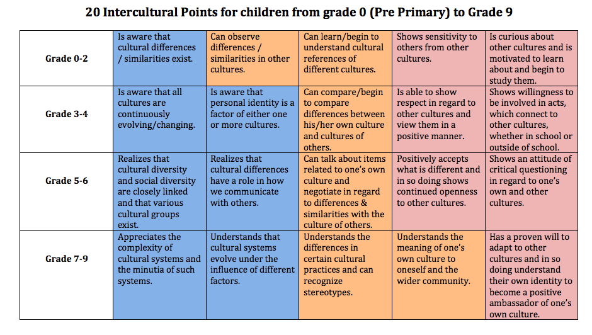
And its matching counterpart

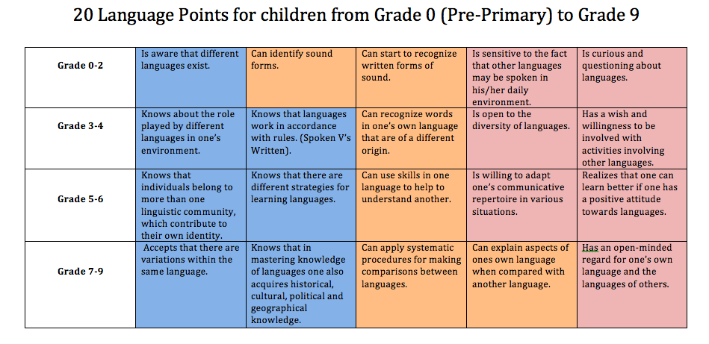

The brief I was given was to go deep inside the FREPA descriptors and bring out a core view, one that encapsulated the ideal of the original, but was accessible to teachers & educators at a glance.

SEE: Original FREPA Descriptors across the curriculum

SEE: Original FREPA Descriptors with Sub Points.

We took the original FREPA descriptors, which are extremely in depth and full of a wealth of educational points and attempted to distill this down to 5 core elements for each grade section. Two for primary,

0-2

3-4

And two for secondary,

5-6

7-9

This was not an easy task, as the FREPA descriptors held so much of value that to distill them down without devaluing them seemed daunting, and to this point we have endeavored to make sure that each point within our new grid can be backtracked to the original descriptor idea/ideas.

Our first step was to try to bring all of the disparate sections of the FREPA descriptors together; we achieved this, by painstakingly going through the originals and bringing each element together within a word document.

An example:

PowerPoint Source for Knowledge/Culture, Skills and Attitude
For Grades 0-2

K8 Essential

Possesses knowledge about what cultures are/how they work.

K8.2 Useful

Knows that a number of cultures, more or less different exist

K8.4.1 Important

Knows that some of the rules/norms/values relative to social practices in other cultures in certain domains (greetings, everyday needs, sexuality death etc…)

K9 Important

Knows that cultural diversity and social diversity are closely linked

K9.4 Important

Knows characteristics of their own situation/cultural environment

K10 Important

Knows the role of culture in intercultural relations and communication

With all points from K8 to K13 and all sub section points listed together in the correct places. From Knowledge we moved onto Skills with all points and sub points from S1 to S7, and finally onto Attitudes including again all points and sub points from A1 to A6, A9 to A12 up to A18. However to make things more accessible we did this to a grade level.

0-2

3-4

5-6

7-9

Having this now all in list form and, all sub points in their correct places, we turned our attention to presentation, taking each full grade level list and placing it within a PowerPoint presentation.

Example:
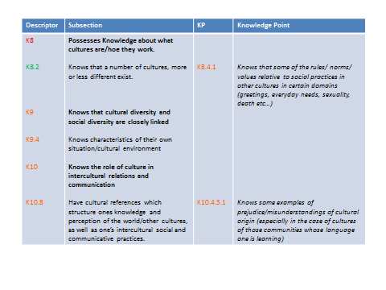
For the full version see the site for Kulttuuritaidon ja monikielisyyden viitekehys
(approachdevelopmenttable formats)/Oulu adaptation. Each level graded PowerPoint presentation was coloured for what we felt were the most relevant points in conjunction with the Finnish context, for example the new Finnish core curriculum.

Once this was achieved, we had all the original material in a viewable grid format, however we now had to bring that down to a single page format for the 5 core points. By doing so, the possibility of tacher´s taking the grid up as support material for his/her teaching would increase. The format of two easlily comprehensible grids only would also help in curriculum design at school and local level.

It was a long process that allowed us to take out what we felt were the core points that should be focused upon in our grid, we looked for points from the teachers & educators perspective IE what should they be looking at in their students, and we also looked at what the student would need to take from this grid, and in so doing we created a single question for each descriptor point.

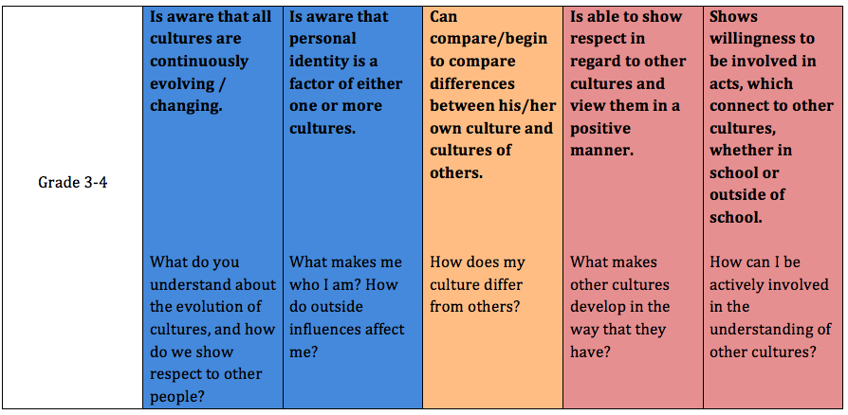
For example if we look at :-

(C) Grade 3-4

Is aware that personal identity is a factor of either one or more cultures.

That is a great point but what does it mean to the child?

What makes me who I am? How do outside influences affect me?

When the point is paired with the question it becomes far clearer for the child, and anyone not conversant in what FREPA is trying to achieve.

In fact here we see how adaptable the grid really is. What other questions can relate to this point?

How has the culture of my family influenced who I am?

How has the culture of the country I live in influenced who I am?

How have the friends I choose to identify with influenced who I am?

In the creation of these question points we felt it gave the grid a possibility of much wider use than inside the educational establishment, with these questions it also gives the parents an open view of what we are trying to achieve within the system, and how we are hoping that each child is able to understand more about the cultures and languages that surround them.

Once created the grid was then translated into Finnish, which I will admit to you was a task unto itself, and I think or at least I hope it helped me to develop my Finnish more, if not in speaking then at least in understanding the difficulties of its structure.

