A Framework of Reference for Pluralistic Approaches to Languages and Cultures Yerevan State Linguistic University “Brusov”

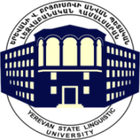
September 10-11
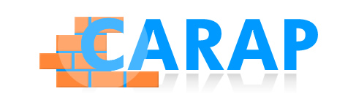

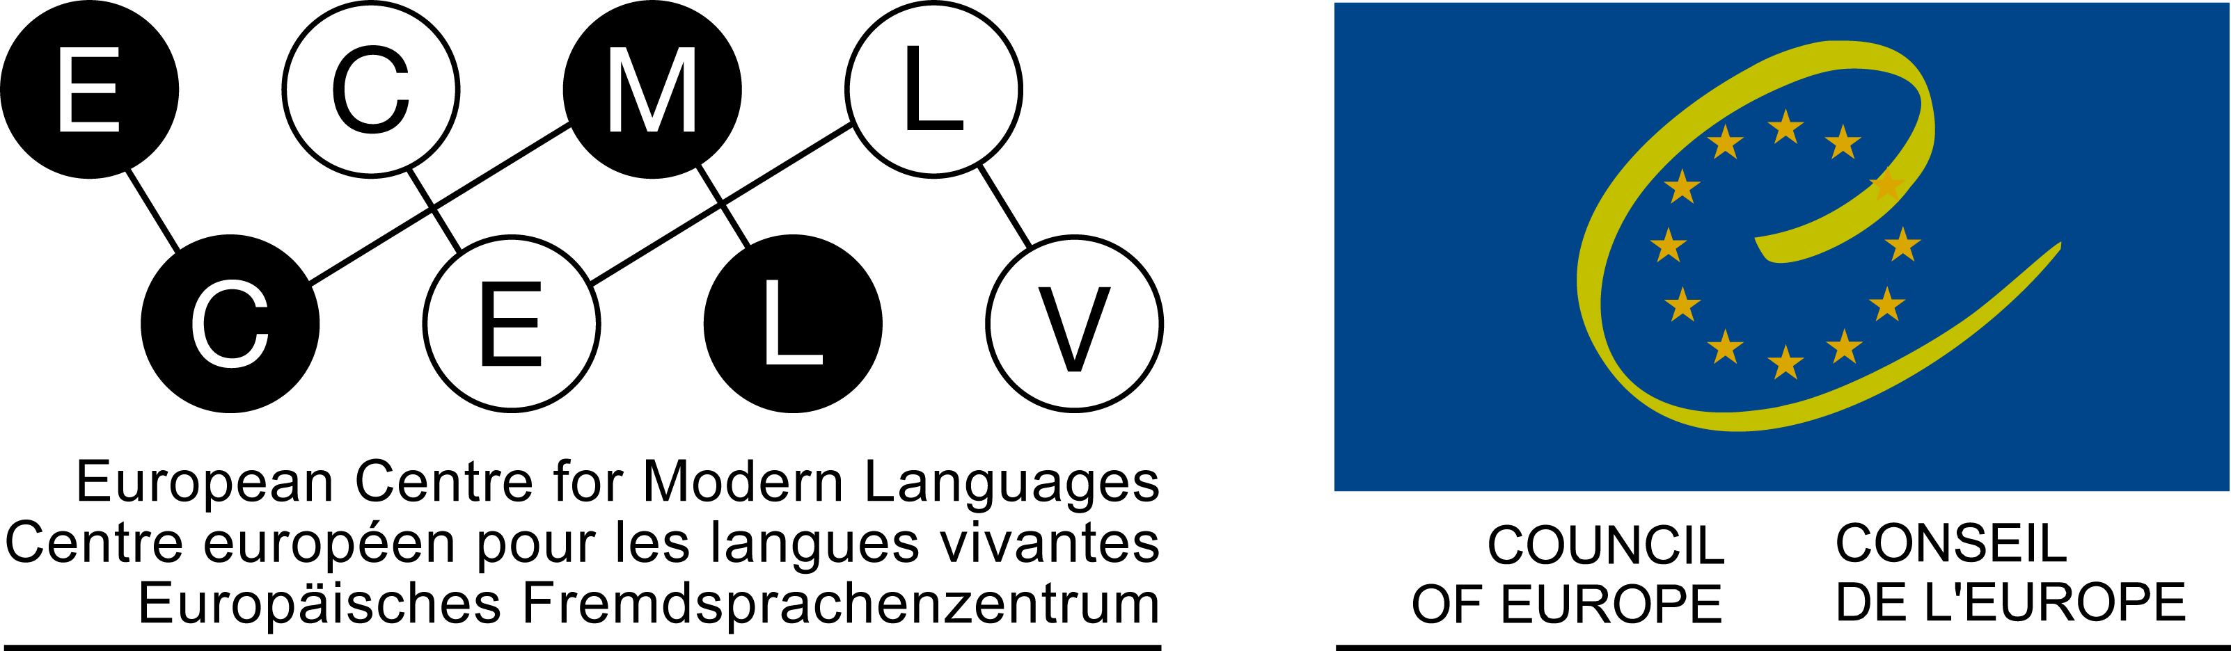
TUESDAY September 10th

9.00 – 9.30

9.30 - 9.45

Registration
Opening Speech by Lusine Fljyan, YSLU Vice-Rector on Science and International Relations
Small Conference Hall

9.45 -10.45

Introductory workshop
Language of Workshop: Armenian
Marine Kharatyan, YSLU
Room: Small Conference Hall

Introductory workshop
Language of Workshop: English
Anna Schröder-Sura, ECML
Room: 407

Introductory workshop
Language of Workshop: English
Michel Candelier, ECML
Room: 414

10.45 -11.15
COFFEE BREAK
11.15 – 12.45

Presentation:
FREPA – A set of instruments for the development of plurilingual and intercultural competences
Michel Candelier, Anna Schröder-Sura, ECML
Small Conference Hall

12.45 – 14.00

14 00- 15.15

15.15 – 15.45
15h45 – 17h

LUNCH BREAK

Using FREPA tools
(and discovering Awakening to languages activities for students at secondary level)
Language of Workshop: English
Anna Schröder-Sura, ECML
Computer room : 407

COFFEE BREAK

Integrated didactics:
German after English
Language of Workshop: English
(recommended for teachers of German)
Anna Schröder-Sura, ECML
Room: 407

Using FREPA tools
(and discovering Awakening to languages activities for young learners)
Language of Workshop: English
Michel Candelier, ECML
Computer room: 414

Integrated didactics:
French after English
Language of Workshop: English
(recommended for teachers of French)
Michel Candelier, ECML
Room: 414

WEDNESDAY September 11th

9.00 – 10.15

Intercomprehension
(between Farsi and Armenian)
Language of Workshop: Armenian
Azatuhi Abrahamyan, YSLU
Room: Small Conference Hall

Intercomprehension
(between Slavonic languages)
Language of Workshop: English
Anna Schröder-Sura, ECML
Room: 407

Intercomprehension
(bet. Romance /or/ Germanic lang.)
Lang. of Workshop: EN / FR / DE
Michel Candelier, ECML
Room: 414

10.15 -
10.45 COFFEE BREAK

10.45 – 12.00

12.00 – 13.30

13.30 – 15.00

Intercultural approach
Language of Workshop: English
Anna Schröder-Sura, ECML
Computer room: 407
LUNCH BREAK
Learning to learn
(At higher secondary and university level)
Language of Workshop: English
Anna Schröder-Sura, ECML
Computer room: 407

Intercultural approach
Language of Workshop: English
Michel Candelier, ECML
Computer room: 414

Learning to learn
(at primary and lower secondary level)
Language of Workshop: English
Michel Candelier, ECML
Computer room: 414

15.00 – 15.30
15.30 – 17.00
COFFEE BREAK
Final discussion: The Relevance of Pluralistic Approaches and FREPA in Armenia – Towards projects
Michel Candelier, Anna Schröder-Sura, Anna Azaryan, Ani Shahinyan
Small Conference Hall

