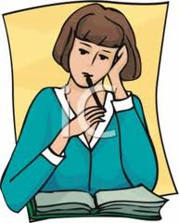 | The Guide and my national documents and textbooks  Sheet 3  Let’s think | 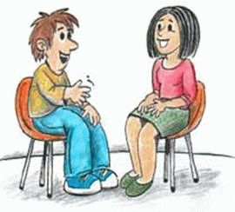
Once more, this document is meant only to help you to think by structuring your reflections. It is very beneficial to work in collaboration with colleagues from your country, taking the time, if necessary, to reread national documents and to share out textbooks (even those related to other disciplines) (It is also possible to work together if you are not from the same country: the fact that you have to explain to others often helps one to understand one’s own specificities!)
N.B. : Of course, it is also important to keep in mind the sheets you have completed previously concerning your own ideas and those of the Council of Europe. .

 | 1- Your official national documents  - Are they closer to your own idea of what is desirable than those expressed by the Guide?  - Which main differences can you identify?
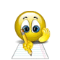 |  | >>

2-Your textbooks
Same questions, look at what they say explicitly (in the pedagogical advice they give to teachers, for example) and what the contents and activities proposed say … implicitly …
- Are they closer to your own idea of what is desirable than those expressed by the Guide?
- Which main differences can you identify?
>>

3 - The origins of these differences (in relation to the Guide)
To what extent can you explain the differences which you have observed in 1 and 2 between these documents and textbooks on the one hand, and the stand taken by the Guide on the other, as …
- national (or regional) specificities?
- teaching traditions (not linked directly to the specificities mentioned above)?
- other factors (can you identify these)?
>>

4 - The origins of your own views
- To what extent do your feel that your views of what is desirable are influenced by the official national documents and the textbooks you have scrutinised ?

>>

Syllabi, currucula, programmes…

